Risk Profiler

View By:

Earthquake Scenarios Probabilistic Risks Training Download About Contact

**Scenario Name: Mw 9.0 Cascadia Interface**

This is a moment magnitude 9.0 earthquake on the Cascadia Subduction Zone. Earthquakes like this occur about once every 400-500 years, with the most recent event in January 1700."

**Deaths: 23423 for Scenario/Muncipality Damage: 23412 for Scenario/Municipality Dollars: $23232 for Scenario/Municipality**

Select indicator:

Fatalities

# Without

# Retrofit

# With

Retrofit

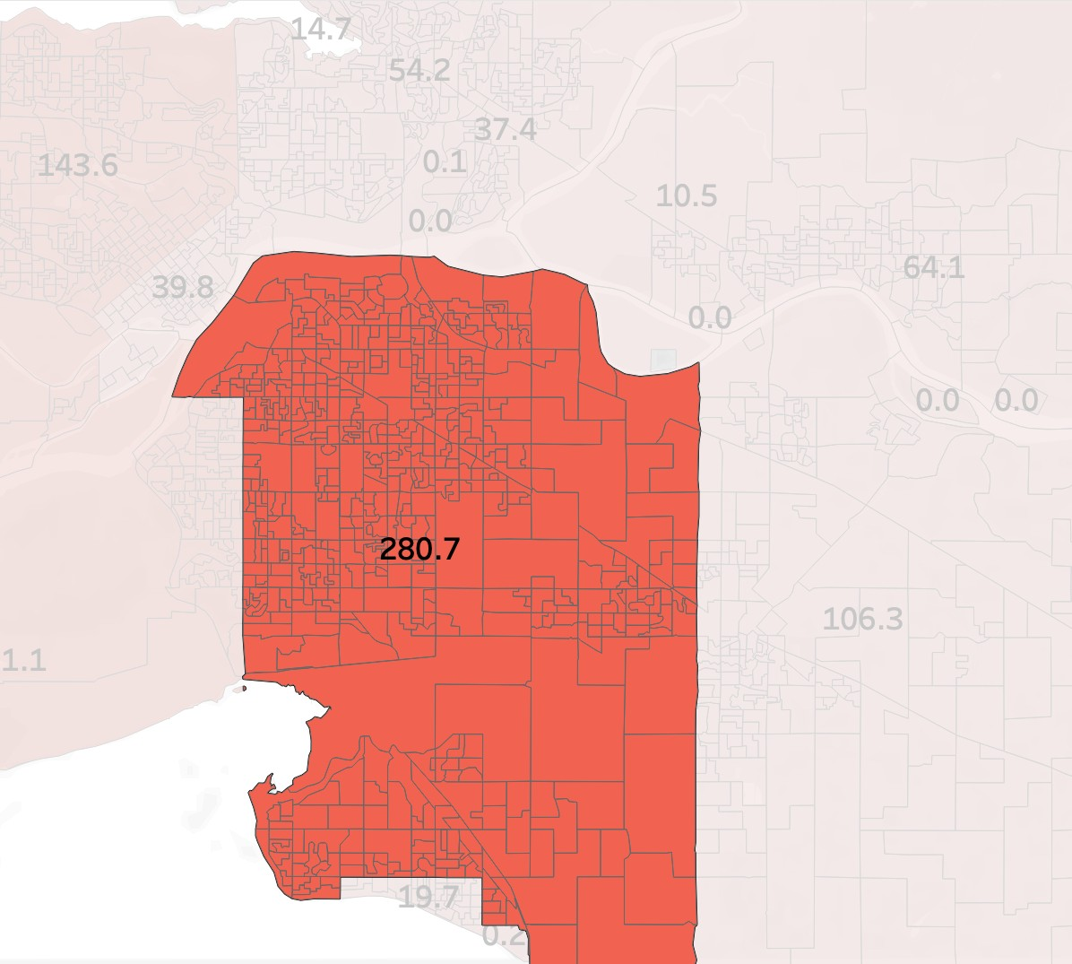

or View List

**Municipality** > **DA 897987**

**+**

**-**

Go

Search By Metro Region or Municipality

Back to Scenario

Back to:

Scenario Catalogue

New? Take The Tour



Footer

